***Service SOAP Steps***

1. *Create a Service Package Rule*

*IntegegrationResources->ServicePackage*

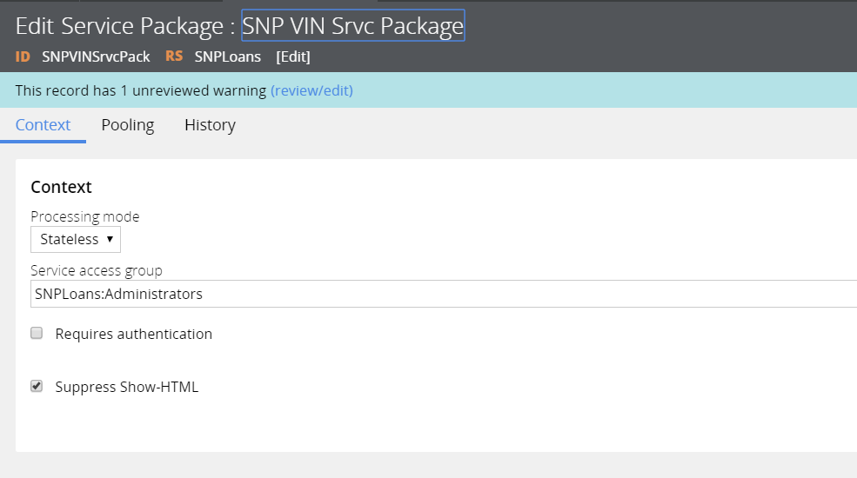

1. *Create a Data Classes ( for Request and Response)*

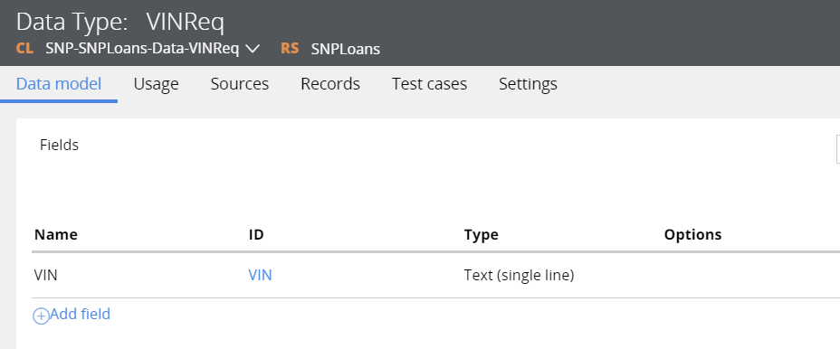

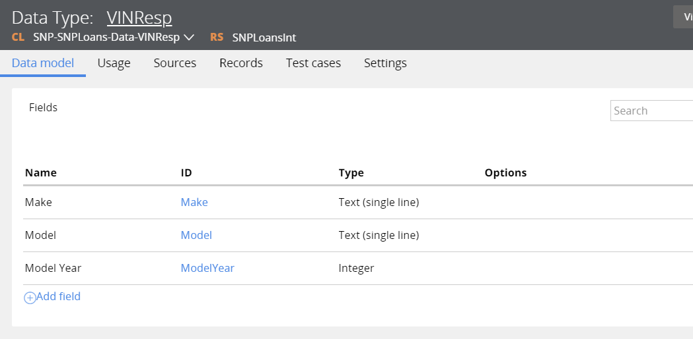

1. *Create a new Class for Service (SNP-SNPLoans-Int-VINDetailsSrvc)*
2. *Craete Request and Response page properties, while creating provide the Req and Resp data classes as Page definitions.*
3. *Create a Service SOAP rule ,Create a below Parse XML and XML Stream from the Service SOAP rule itself*

*5.1)Create a Parse XML Rule*

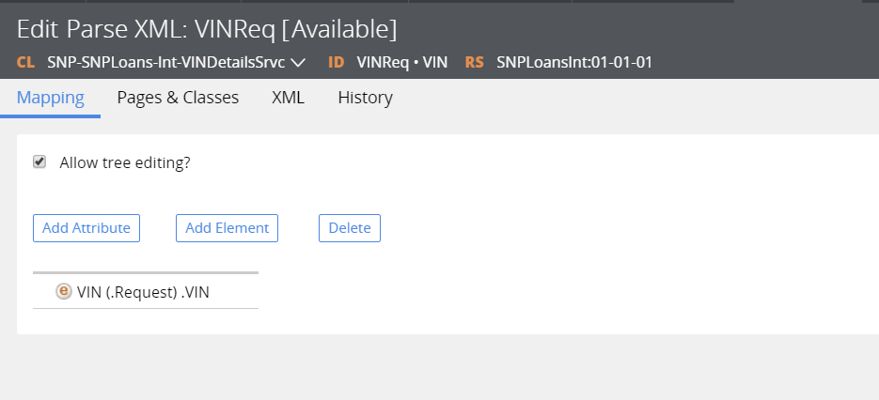

*5.2)Create a XML Stream rule*

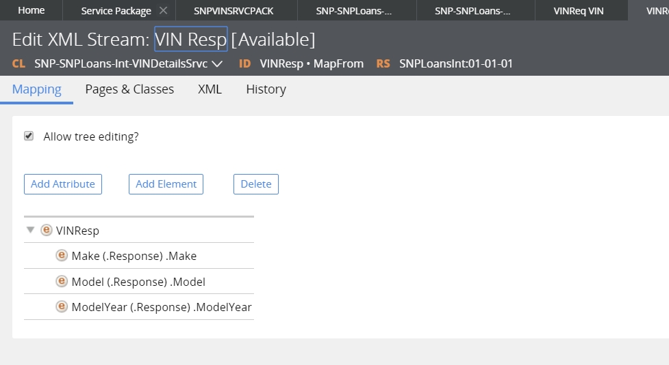

*5.3) Create Service Activity*

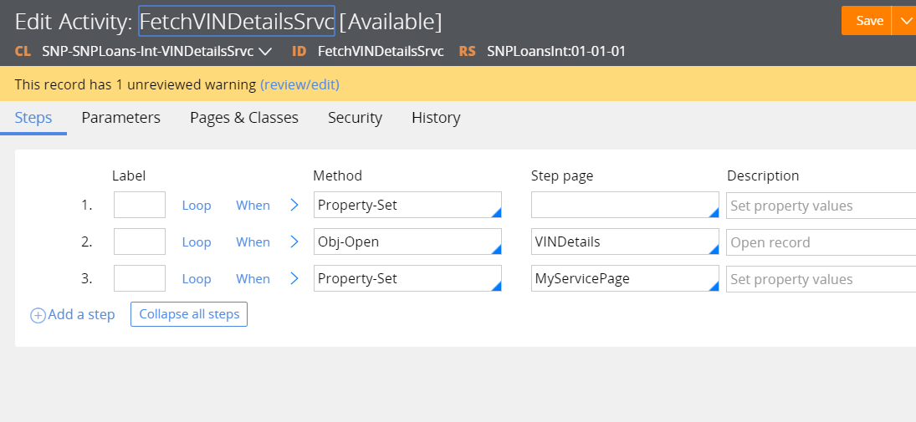

*And save the Rule , Goto Service Package and Refresh the methods for WSDL , then Create the Connect SOAP integration by using WSDL.*